Per our Founder, Lord Baden-Powell
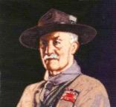
Note – The original Scout Law published in 1908 had 9 points. In 1910, the BSA added Brave, Clean, and Reverent. In 1911 B-P added Clean to his original list.
A SCOUT'S DUTY TO GOD
"No man is much good unless he believes in God and obeys His laws. So every Scout should have a religion....Religion seems a very simple thing: First: Love and Serve God. Second: Love and serve your neighbour." - (Scouting For Boys, 1908)

Be a player on God's team.
Lord Robert Baden-Powell, Rovering to Success, 1922

